Ecosystem Description

Aniko B. Toth

## Ecosystem Env1_sdm3 Mesic coastal lowlands

Env1_sdm3 Mesic coastal lowlands. Rocky lowlands in warm, cloudy mesic areas support a biota dominated mainly by lichens, mosses and seabirds. Colonies of penguins on the lower slopes and nesting seabirds influence moss beds upslope enriched by nutrients via updrafts. Grasses occur occasionally within this system at low elevations on the Antarctic Peninsula and associated islands, but not in other areas. The microbiota is likely to exhibit strong regional variation within this unit around the continent.

### Photos (if available)

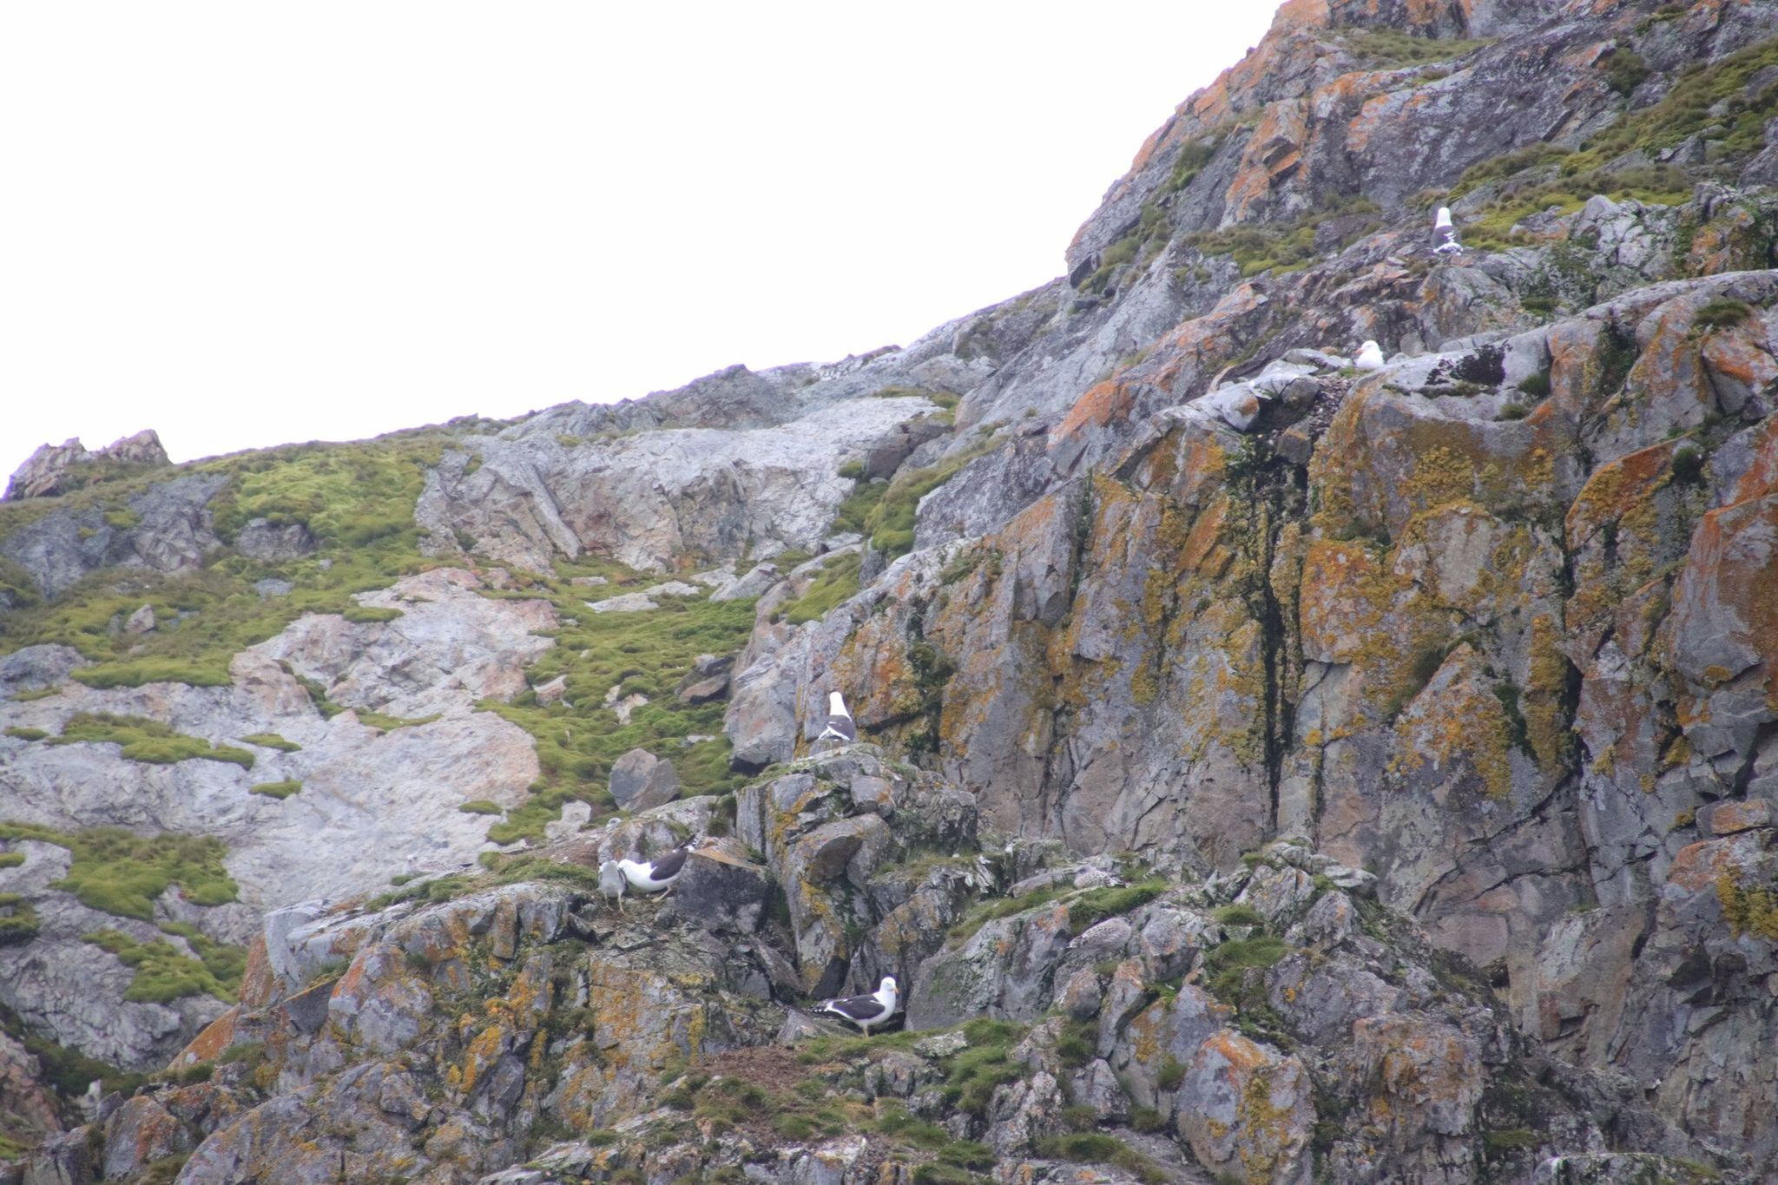

Ecosystem photo

### Distribution

Maps - Full map

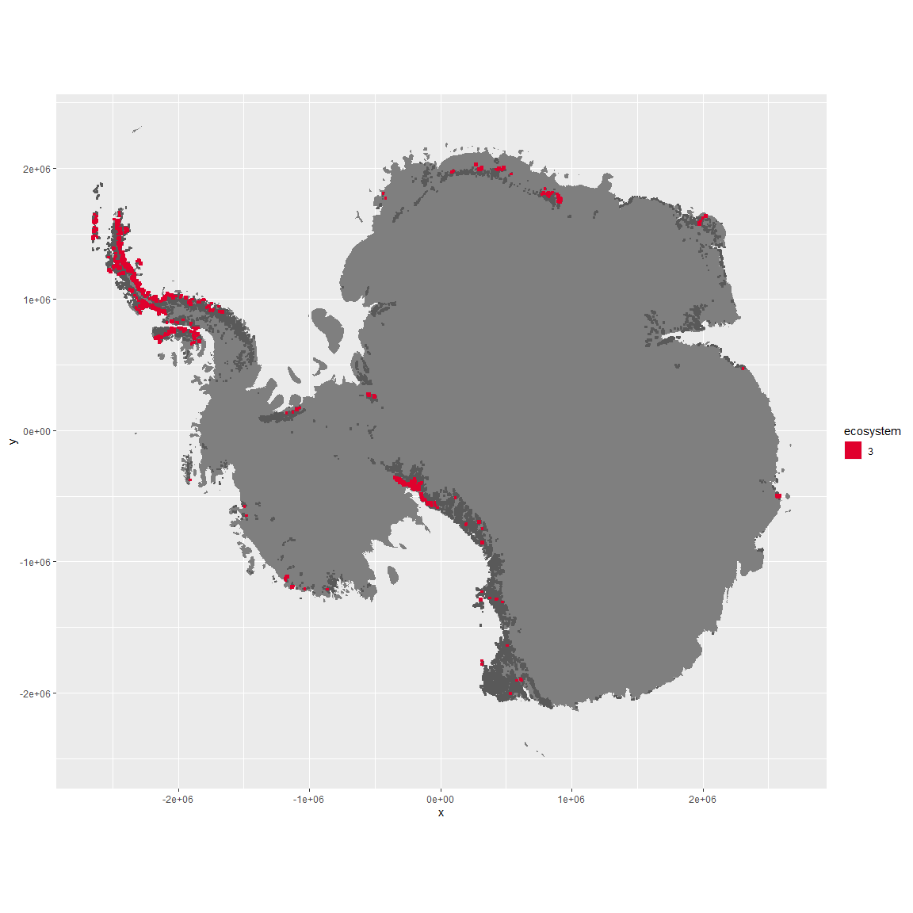

Regional maps

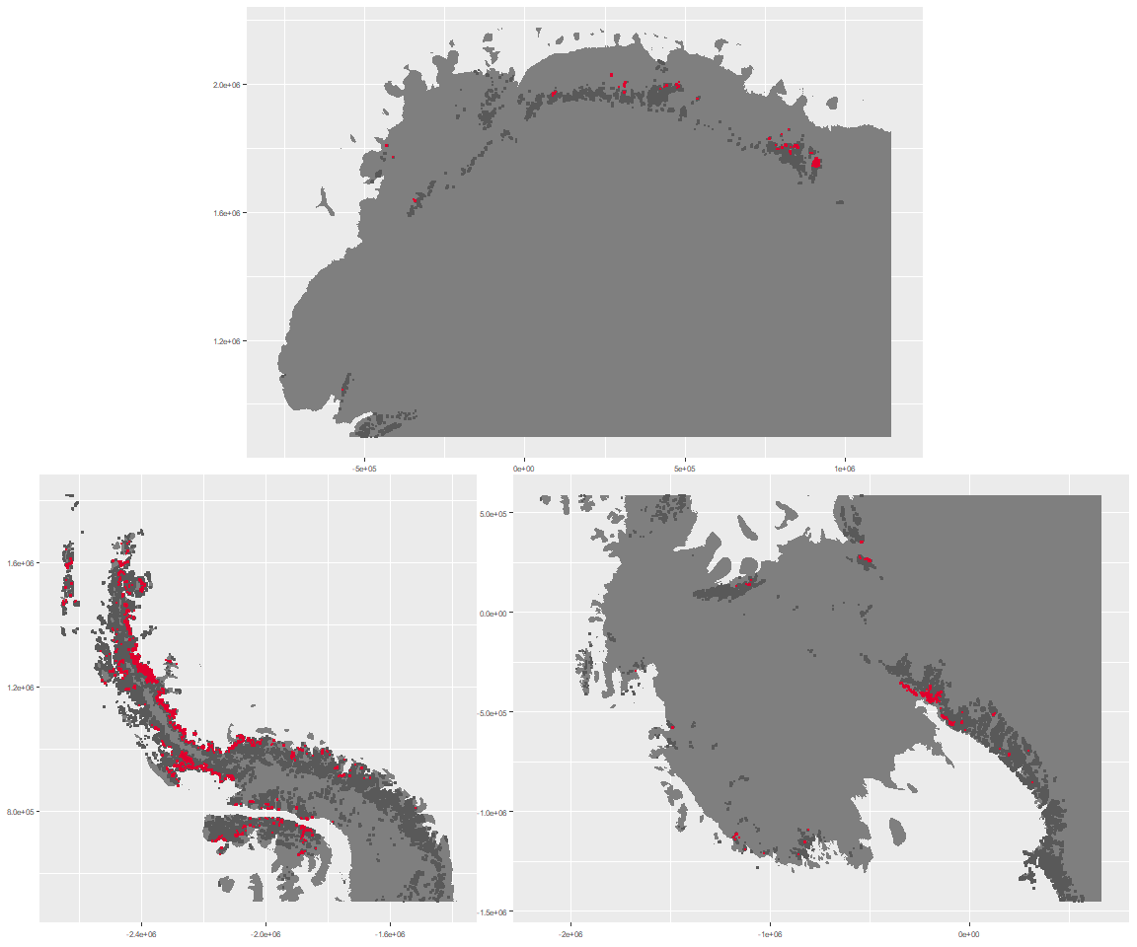

### Environment

The unit env1_sdm3 is part of the environmental supergroup env1.

This supergroup is, on average, substantially higher in sumtemp, temp, modT_0315 and melt than continental antarctica. It is substantially lower in slope, rugos and elev than the rest of the continent.

The elevation of unit env1_sdm3 ranges from 0 to 1984 metres above sea level, but 90% of its pixels fall above 18 and below 1107 metres. Its average elevation is 466 metres.

The unit is higher in cloud, melt, temp, wind, DDminus5, precip and sumtemp and lower in no variables than the rest of its environmental supergroup.

#### Distinctiveness of the unit from its group and the rest of Antarctica

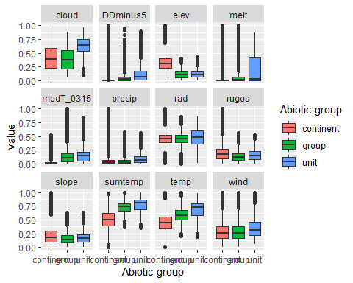

### Biota

Most widespread species in the unit (found in most pixels)

The top most widespread species in ecosystem env1_sdm3

| scientific | Functional_group | phylum | restricted | count | relative_pct |
| --- | --- | --- | --- | --- | --- |
| Polytrichastrum alpinum | Bryophyta_Bryopsida_Polytrichales___ | Bryophyta | FALSE | 21 | 1.1925 |
| Syntrichia princeps | Bryophyta_Bryopsida_Pottiales___ | Bryophyta | FALSE | 21 | 1.1925 |
| Ceratodon purpureus | Bryophyta_Bryopsida_Dicranales___ | Bryophyta | FALSE | 20 | 1.1357 |
| Andreaea gainii | Bryophyta_Andreaeopsida_Andreaeales___ | Bryophyta | TRUE | 19 | 1.0789 |
| Cryptopygus antarcticus | Arthropoda_Entognatha_Entomobryomorpha___ | Arthropoda | TRUE | 19 | 1.0789 |
| Sanionia uncinata | Bryophyta_Bryopsida_Hypnales___ | Bryophyta | FALSE | 19 | 1.0789 |
| Pohlia nutans | Bryophyta_Bryopsida_Bryales___ | Bryophyta | FALSE | 18 | 1.0221 |
| Pygoscelis adeliae | Chordata_Aves_Sphenisciformes_Spheniscidae_Pygoscelis_adeliae | Chordata | FALSE | 18 | 1.0221 |
| Umbilicaria decussata | Ascomycota_Lecanoromycetes_Umbilicariales_Umbilicariaceae__ | Ascomycota | FALSE | 16 | 0.9086 |
| Usnea antarctica | Ascomycota_Lecanoromycetes_Lecanorales_Parmeliaceae__ | Ascomycota | FALSE | 16 | 0.9086 |

This supergroup is, on average, substantially higher in suitability for Rotifers, Springtails_slim, Nematodes, mosses_Pottiales, mites_Trombidiformes, lichens_Physcid_(shadow), lichens_Teloschistid, lichens_Candelarid, mites_Sarcoptiformes, algae_Green, mosses_Dicranales, lichens_Lecanorid, lichens_Parmelid, lichens_Rhizocarpid, mites_Mesostigmata, lichens_Acarosporacid, lichens_Stereocaulid, Algae, mosses_Bryales, penguins_Gentoo, mosses_Hypnales_(feather), penguins_Chinstrap, mosses_Polytrichales, lichens_Cladonid and lichens,_Bacidiacid functional groups than continental Antarctica. It is substantially lower in suitability for no variables than the rest of the continent.

Unit env1_sdm3 is higher in suitability for lichens_Parmelid, lichens_Stereocaulid, lichens_Rhizocarpid, mites_Sarcoptiformes, mites_Mesostigmata and mosses_Polytrichales and lower in suitability for Rotifers than the rest of its environmental supergroup.

Distinctiveness of the unit from the environmental group and the rest of Antarctica

